Blue Bear
An A3 sheet of newsprint with a figure of a teddy bear painted in teal.
The bear is scruffy and has a rather rueful expression on his face, whose features are drawn in pen. Further features drawn in pen include his feet (unpainted) ??, eyes and nose and buttons down his middle.
Penned arrows project horizontally from his hands and vertically from his feet. The whole is encased in squiggles. (EOD)

Blue Bear 2 (TS)
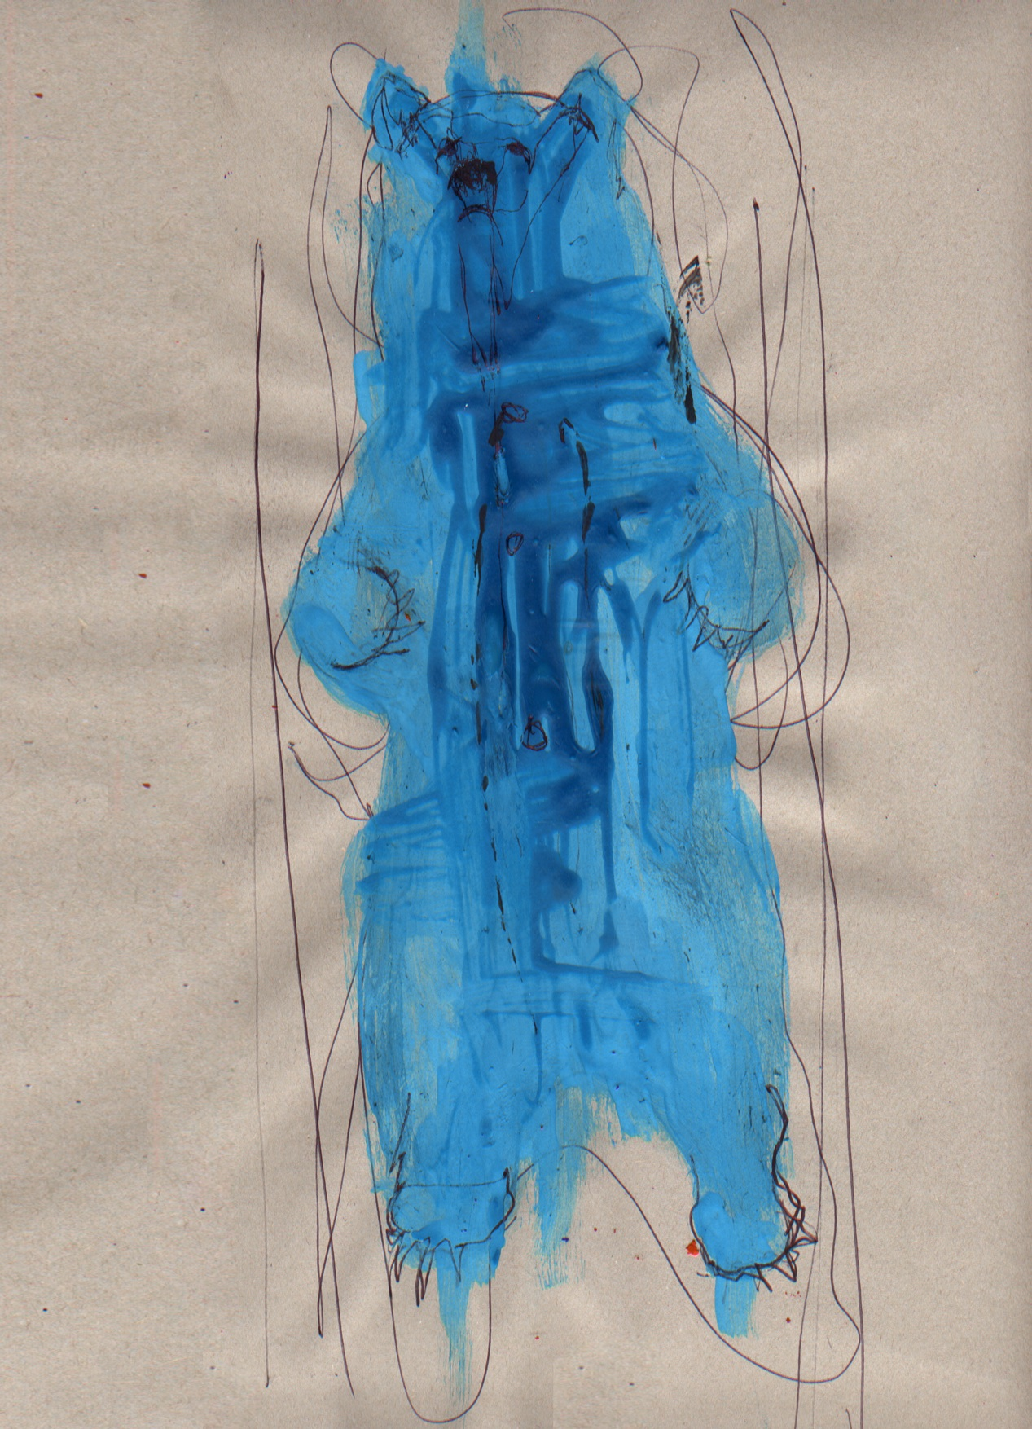

'Raahhhh.'
It made me smirk and gave my tummy a warm and tingly feeling, cute and squiggly feet and paws. Soft brown nose and bubbly blue all over....... (SH)

Blue Bear 3 (HR)
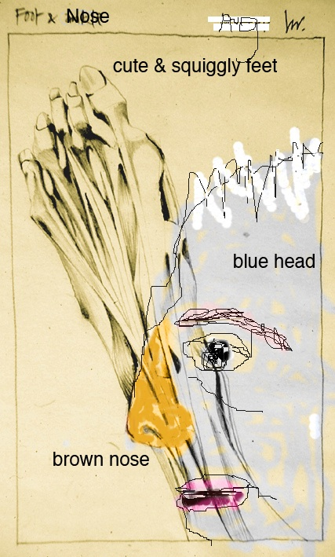

The drawing has a overriding digital quality with very pixilated thin black scratchy lines to create the side profile of a face in the bottom right hand corner of the page, the hair, nose, eyes, eyebrows and outline of lips can be seen in this black line. The nose is a thicker softer overlaying line of mustard yellow, there is a hint of dark pink, wine red blur on the lips. The overall background colour of the paper is creamy brown like a tea stain, a scribbled thick white line outlines the hair like a zig zag. There is an inner drawn frame line and within in behind the face emerging upwards toward the left top corner is a scanned pencil drawing in detail
of a horrible boney foot shape with long toe nails, the drawing is shaded to highlighted to enhance veins, bones and tendons. There is typed text on the drawing at the top is 'cute squiggly feet' on the face is "blue head" the background to the face incidentally is a place grey scribble. The word 'brown nose' is at the side just under the nose. Out- side the frame at the very top left corner handwritten is the word 'foot &' in type is 'Nose' further along is some kind of white block with random signature. (AL)

Blue Bear 4 (KC)
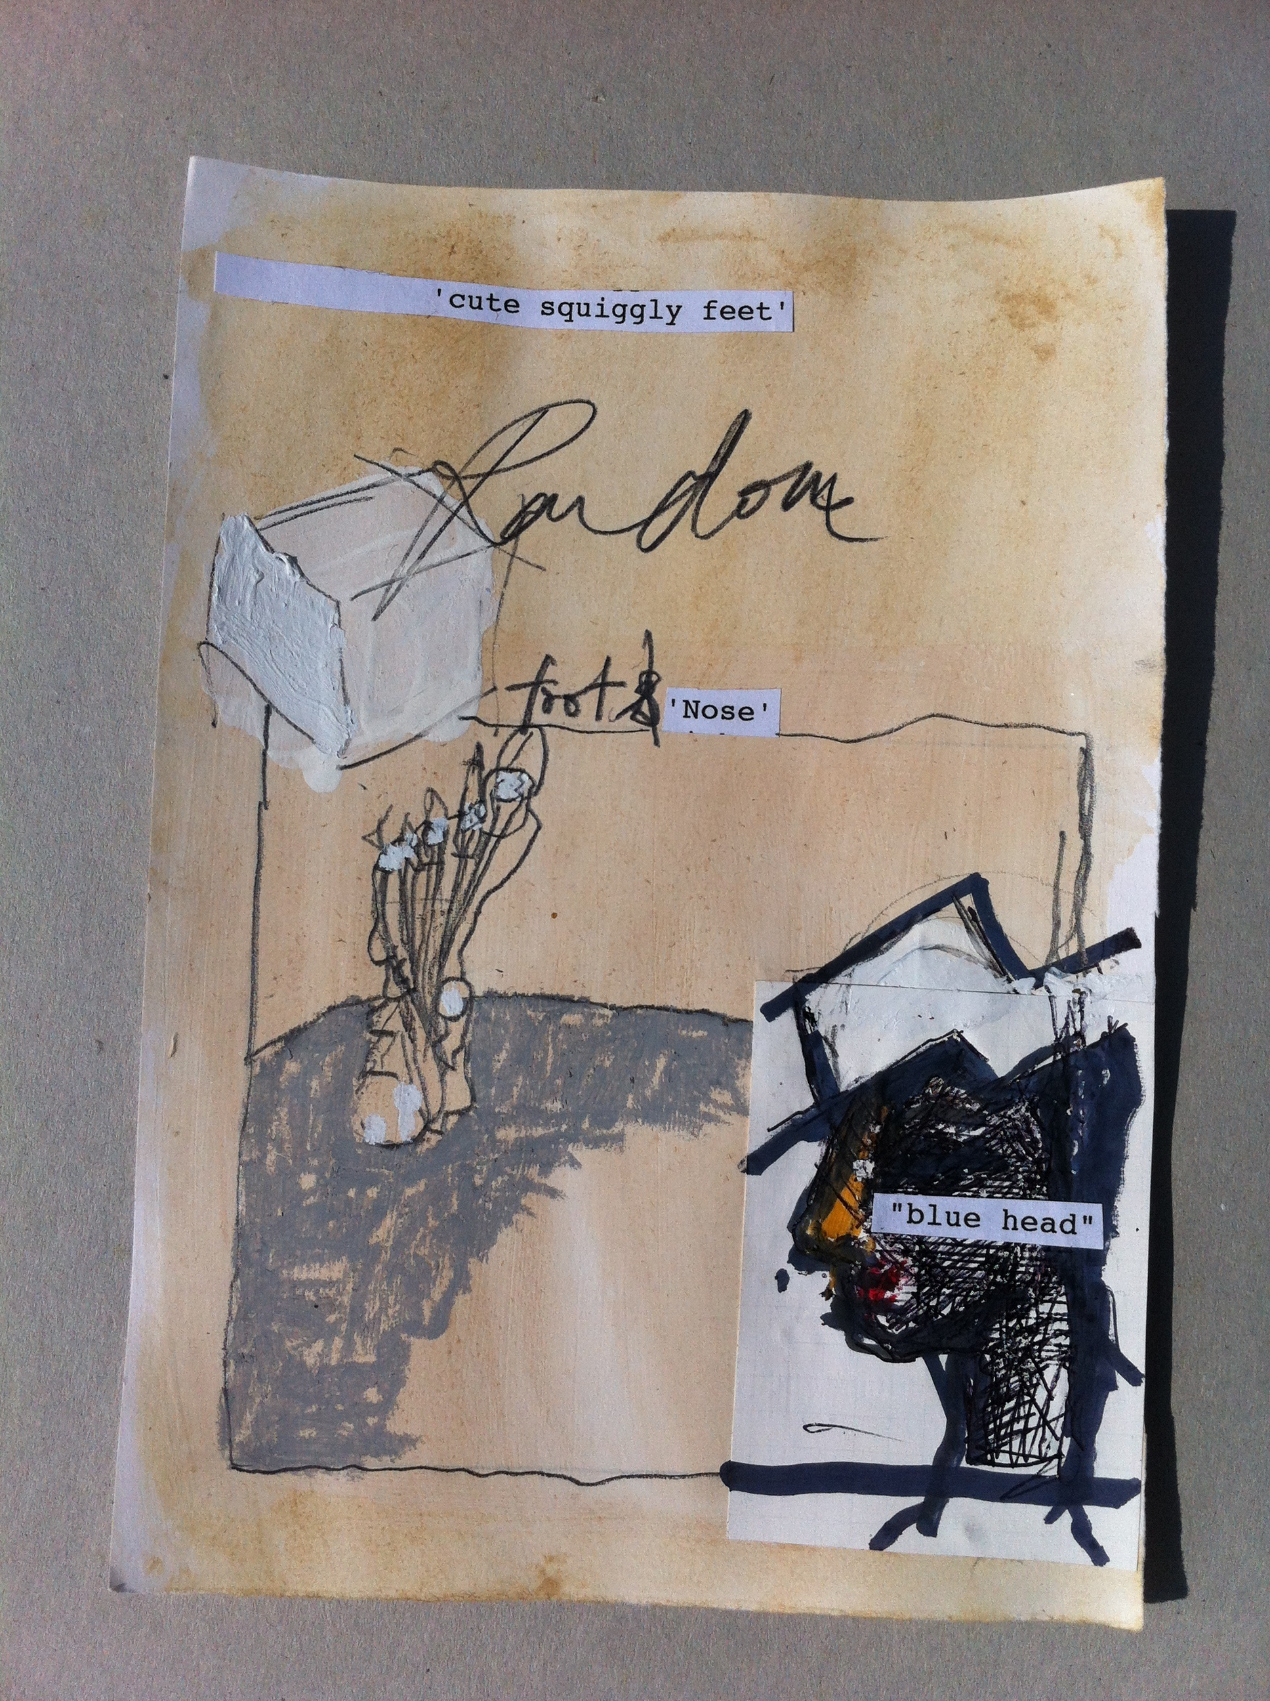

Rough-hewn mixed-media
handwriting, type, square, cube, figure.
Almost a piece of comic strip.
How big is it (BD)

